Noah DuVal (nbduval2)

Jason Wright (jasonlw2)

ECE 385

Final Project Proposal

1. Idea and Overview
   1. We propose to build and design the 1985 version of Super Mario Bros by Nintendo. We plan to have a starting screen with a menu where you select to play as Mario or Luigi. To start the game will consist of a single level and we will plan to add more if time permits. In addition, we plan to implement the famous background music for the game as well as character animations. Another possible addition will be enemies and bosses such as the mushrooms and turtles that roam the floor on the levels. The final design will also contain a few stats at the top that are included in the original games such as the time, score, coins collected, and current level.
   2. In terms of equipment used we plan on using either the IO shield, a keyboard, or an Xbox controller to play the game in the final product. As well a speaker to output the sound if we choose to implement it.
   3. As far as where the features will be implemented most will be using hardware (SystemVerilog) such as the game logic. The rest will be using software (C Code) to connect all of the pieces together such as loading up the levels and initializing the game. As well as statistics kept such as the time, score, and coins collected. Theoretically, the design could be implemented entirely on hardware if we decide. Lastly, the only thing that we can think that we will pull from outside sources will be the sprites. However, it is also possible that we will make them ourselves if we can not find a source that will work.
2. Block Diagram (tentative)

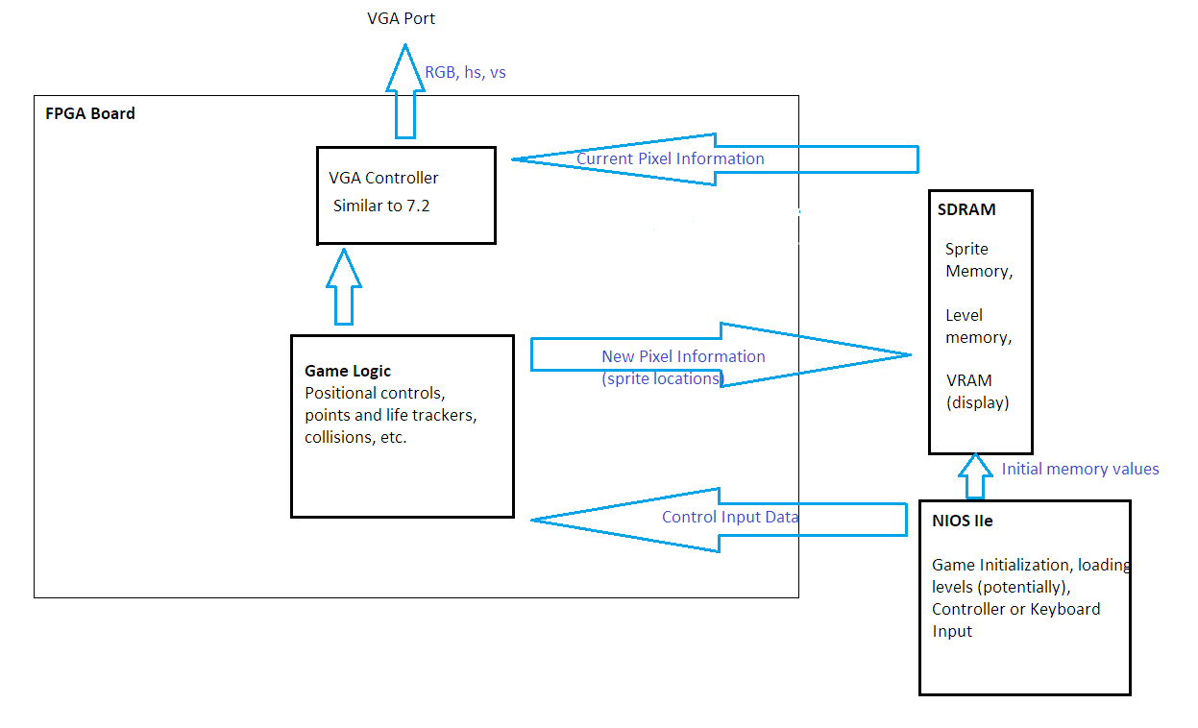

1. List of Features

i. Baseline Features:

* Accurate physics for movement speed and jump height
* Enemy behavior and player death mechanics
* Win condition (flag)
* At least one playable level
* Color 8-bit graphics with player and environment sprites

ii. Additional Features:

* Working score counter and life counter
* Audio for game effects (jumping, collecting coins, etc.) and background music
* External gamepad support (probably an xbox controller connected through usb)
* Additional levels
* Full main menu and additional settings options
* Improved (16-bit) graphics and better animations

1. Expected Difficulty

While we are unsure of the scale and what accounts for X amount of points. We think that our baseline project will consist of around 5 difficulty points and if all features are implemented it would end at around 8 points. The reason for this rating is that we believe most of the basic game components will be fairly simple to implement based on previous labs, but will still require some work to get done. In terms of the features we think that this will be around 8 points due to the sound being talked about as being on the more difficult side of things. We think that the statistics will add a few difficulty points, but not a lot. We also believe that if we scale the levels and implement multiple and even possible a boss level with bowser and the more active graphics that take place there it would add more difficulty points. Additionally, we think that the use of an Xbox controller would add additional difficulty points instead of using a keyboard or the IO Shield.

1. Proposed Timeline

Week 1 (Optional Demo): Start on visuals such as sprites and background and vga display.

Week 2 (Mid-Point Demo): Start game logic, be able to display sprites of multiple objects overlaid via buffering, possibly with limited animations, for demo.

Week 3 (No Demo): Have baseline mostly working and be in the debugging stage and begin to move onto difficulty points and scale the game.

Week 4 (Final Demo): Have baseline debugged and fully working with at least a few of the additional features by the start of the week and use the remainder to add the points that are more of a reach.